
Scraps Newsletter
January 2014

President’s Chatter

Time is like a flowing river, no water passes beneath your feet twice, much like the river, moments never pass you by again, so cherish every moment that life gives you and has a wonderful New Year.
We all share a passion for quilting. The CQQ and the CQA are wonderful venues to display your work. The deadline for the Canadian Quilter's Association for the National Juried Show is February 1st 2014. Let us have a good representation from WIQ.
How are the ticket sales for the educational quilt going? Please see Heather if you have not received your booklets.
Are ideas swirling around in your head for the president's challenge? The May meeting is the deadline, for your masterpiece.
Don't forget your mug and your show and tell.
There seems to be no problem with our arriving after 7 p.m. for our guild meeting.

Claudia Gass

Program News

Our Mug Rug exchange at the Christmas Party was a big success! 16 lucky guild members brought home handmade gifts. Thank you for your participation!

The Mystery Quilt instructions for Clue#5 will be e-mailed in the beginning of January. A draw will take place in June and the top must be completed in order to be in the draw. Keep working, ladies!
At our first meeting we will pull the number for the UFO Challenge. Cross your fingers.

At her the presentation Karen Deparois explained how to achieve perfect squares.
Let move to the curves! On January 23th Marina will show how to make perfect circles for appliqué and curved piecing by hand. Please, bring your sewing kits if you wish to give it a try

Terrie Vorsteher and Marina Segalovitch

Happy New Year!

Here’s a look at our program plans for 2014 (subject to change)

January 09 Mystery Quilts Directions

January 23 Perfect Circles for Applique & Curved Piecing - Marina

February 13 Mystery Quilt Directions

February 27 TBA

March 13 Mystery Quilt Directions

MARCH 21-22-23 RETREAT

March 27 Borders, Borders, Borders! - Dominique Erhmann

April 10 Mystery Quilt Directions

April 24 TBA

May 08 Directions for Mystery Quilt

May 27 TBA

June 12 Deadline to show your finished Mystery Quilt Top
Draw for Fat Quarters Prize for finished Mystery Quilt tops
Draw for finished UFO's participants
Final Meeting/dinner/activity

Heather Dubreuil of the Beaconsfield Quilt Guild asked to share the following with our members:

SAQA (Studio Art Quilt Associates) is an international organization with over 3000 members, devoted to the promotion of art quilting. The Central Canada region (Quebec and Ontario) has assembled an exhibit titled "Synthesis II", with 20 works by 16 artists, which will be on display in the Kirkland Library this February. This show has already toured seven Ontario galleries, and has been very well received.

At the same time and in the same gallery, SAQA member Heather Dubreuil will show her Cityscapes series.

www.heatherdubreuil.blogspot.ca
www.heatherdubreuil.com
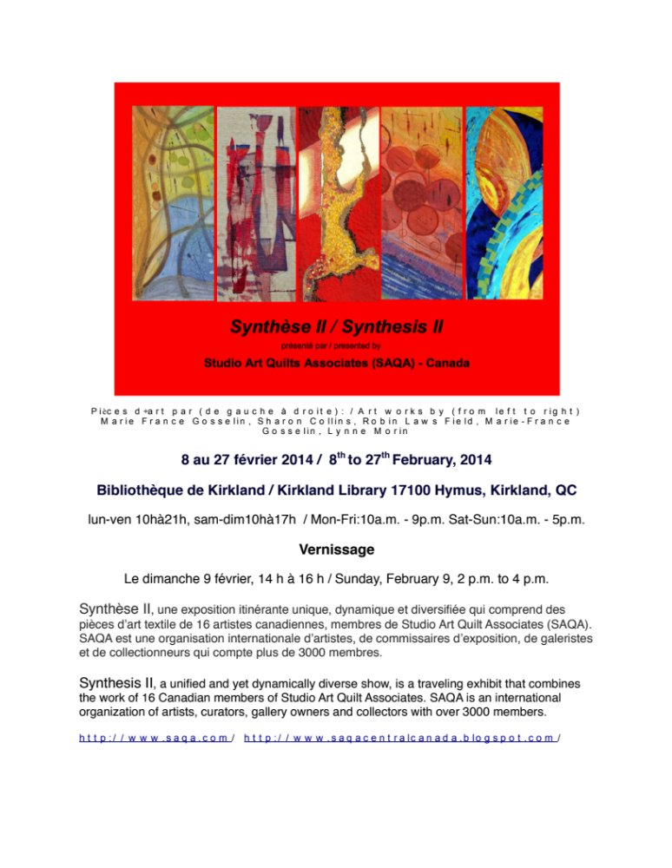
JN Harper Challenge:
All of the items submitted as part of the “GARDEN OF HOPE” challenge will be judged to select the first, second and third-place winners. The winners will respectively receive purchase certificate of JN Harper fabrics. See rules on the CQQ website…
1st prize: $300. 2nd prize: $200 3rd prize: $100
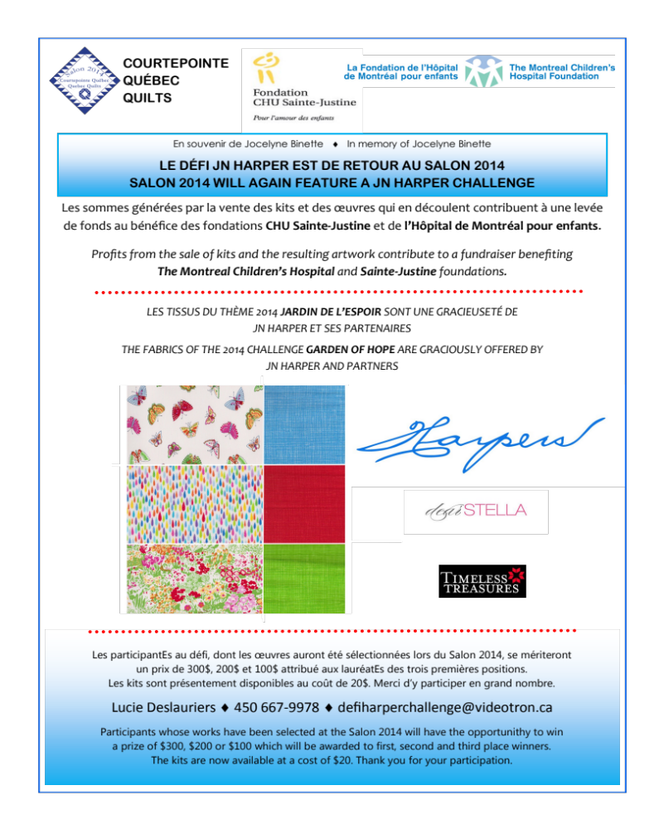
Odds and Ends
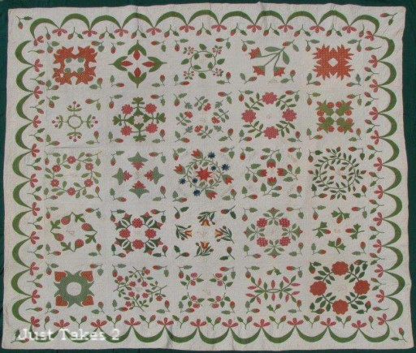
Looking for a new free project, called the Benjamin Biggs quilt – check out the following link:
www.http://justtakes2.com
each month on the first, they will post a new block which you then download and print. They also provide a little history on each block. Looks interesting, no…??

The first block for January is called Apple Pie Ridge.
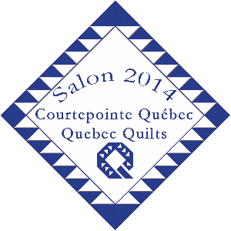OPENING HOURS
Thursday May 29, from 10 a.m. to 8 p.m.
Friday May 30, from 10 a.m. to 7 p.m.
Saturday May 31, from 10 a.m. to 5 p.m.
Sunday June 1st, from 10 a.m. to 3 p.m.

Collège André-Grasset 1001 Crémazie Blvd. East Montréal, QC H2M 1M3
Get ready to book your classes….if you go on the website, choose calendar and then click on each teacher, you will see the quilt in color.
Lots of local talent (including Marina from our own guild!) and its important that we support this show….
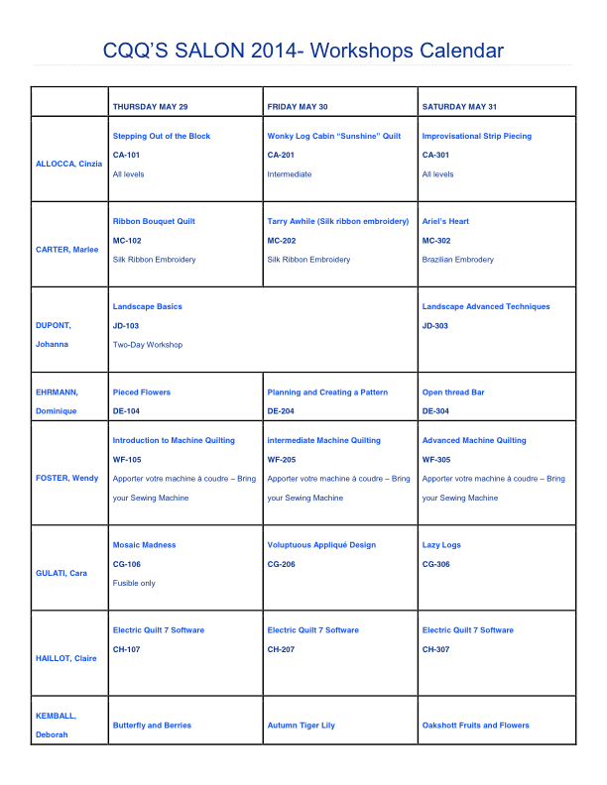
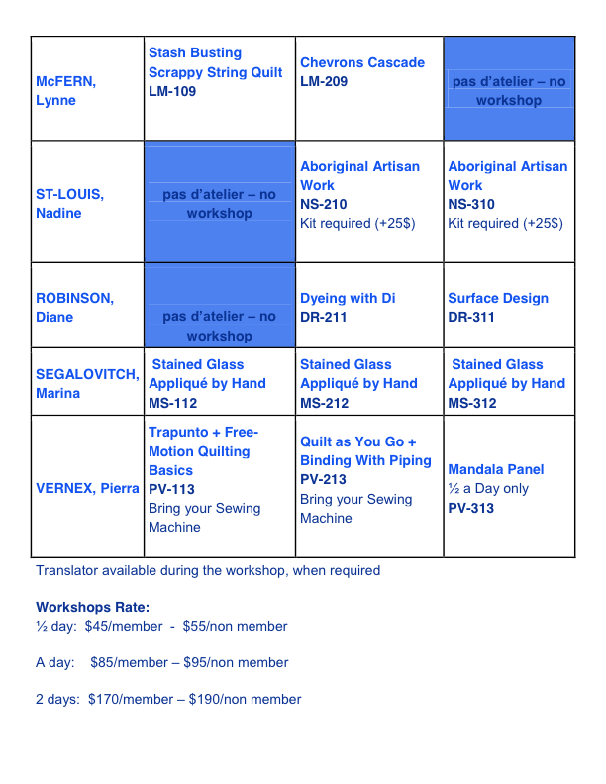

Words of Wisdom
I found I could say things with color and shapes that I couldn’t say any other way—things I had no words for.
Georgia O’Keefe

Results from a medical examiners autopsy of a quilter’s brain!


