

http://westislandquilters.weebly.com

Scraps Newsletter
February 2014

President’s Chatter

This cold weather and icy conditions lends itself to staying indoors and perhaps starting or finishing up those quilting projects.
I have been to 2 quilting retreats in the last 2 weeks and got quite a bit done. WIQ's retreat is March 21st to the 23rd. See the sign up sheet at the back of SCRAPS.
How are those tickets for our educational quilt selling? The new draw date is our meeting on March 13th. Please return all tickets, stubs and cash. Thank you for your effort.
On February 13th Marina and I will do applique demos. I will demonstrate how I proceed to applique the daisy block. If you did not get a package, see Debbie Elliott.
The Canadian Quilter’s show is fast approaching .It is too late to enter a quilt, but you can sign up for courses. The show is in the beautiful Niagara area in Ontario.
The exhibition of Quebec quilts and textile art is May 29th to June 1st. There is still time to enter your quilt and sign up for classes. Speaking of CQQ, I just received by mail several books of tickets to sell. SORRY!!! The" Baroque Beauty" quilt was designed and made by Sheila Wintle who is renowned for the originality and beauty of her quilts.
Happy Quilting

Claudia Gass

Program News

Even though we are in February 2014, it is time to think about the raffle quilt for our 2015 Quilt show. On the last meeting of January, Debbie started distributing packages with applique blocks. For those of us, who want to try it but do not know how, Claudia and Marina will show different methods of doing hand applique on the February 15th meeting.

The Mystery Quilt instructions for Clue#6 were e-mailed in the beginning of February. We start putting it all together.

At our first meeting, we will pull the number for the UFO Challenge.

Terrie Vorsteher and Marina Segalovitch

Finances

With the start of the New Year, we have paid most of our fixed financial expenses, and so far we have paid for 1 guest speaker. (Note: the Wendy Foster workshop was fully paid by the registration fees - $460.00).
We have also started working on our quilt for the 2015 Quilt Show and our projects for charity. Debbie Elliott has purchased fabric for the quilt top and Diane Kehle has bought batting.
Fixed Costs Description | Amount | Total
Church Rent | $920.00
Insurance | $81.75
CQA Membership | $115.50
total |  | $1117.25
Workshops
Cinizia Allocca | $100.00
total |  | $100.00
2015 Quilt Show / Charity
Fabric | $94.85
Batting | $95.48
total |  | $190.33
Miscellaneous
Kettle | $24.96
total |  | $24.96
Overall Total |  | $1432.54

Mary MacMillan
Hospitality

'Many thanks to Eileen Wilson, Liette Coté and Beverly Marsh for the goodies in January.' Ladies, if you have some interesting recipes to share with us, please let me have them so they can be included in the newsletter.

For February, Mary MacMillan and Marie-Josée Glass are signed up for February 13, and Debbie Elliott and Diana Pope for February 27. I know it's Valentine's Day and all, but not ALL has to be chocolate….

Just a reminder to all our members. 'Signed up' means you are responsible to bring snacks, one person brings one liter of 2% milk (refunded upon presentation of receipt) and cleanup. You are asked to bring two fat quarters for the book box draw.

If you are scheduled to bring snacks and are unable to attend, it is your responsibility to find someone to replace you (not the hospitality coordinator). Please refer to the new Member's Orientation Booklet, 2013 Edition, page 8. Also, if supplies are running low, please let me know so I can replenish the box. A new kettle has been added to our kitchen supplies, as well as a first aid kit. Both of these should be returned to the supply box at cleanup and put away, as they belong to the Guild, not the Church.

Many thanks ladies, and keep up the yummy work!'

Andree Claveau-Hoyer

Charity

Just a little reminder of our upcoming Charity Day on March 8th. The church is not charging us for the rental but we are asked to bring canned food for their Food Basket. As previously mentioned, we are supplying your lunch. Hopefully I can persuade Gloria to make us her fabulous soup. Also attending our Charity Day will be members of CQQ who will be registering quilts from our guild. So far we have 19 and need 25.

We will be needing volunteers for the CQQ registration (2 people), help in the kitchen for lunch and of course volunteers for sewing (please bring your sewing machine, kits will be supplied). There is a job for everyone. Come and join the fun.

Diane Kehle

PS Save the environment, and don't forget your scraps or fabric, threads, batting etc. for recycling, I will be collecting.

Library

To date, we have collected $77.00 (Thank-you!) doing our Book Box draws and therefore we have now purchased the following books to add to our library:
Quilting on the Go
By Jessica Alexandrakis
Break free from your sewing machine!
Imagine being able to quilt on vacation, at the beach or virtually anywhere else you find yourself. This book is an introduction to English Paper piecing. This slow sewing movement has been steadily growing in popularity and the book includes a range of spectacular hand projects.
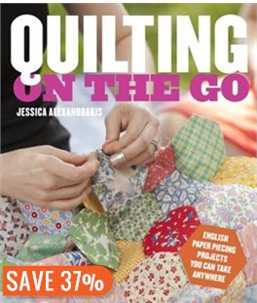

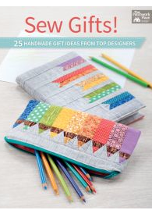
Sew Gifts
By various authors
These cute projects are just too much fun to give them all away. You’ll be able to make just the thing for all those special people in your life. Projects range from a pencil case to pillows and everything in between. (25 projects)
**this book was donated to our guild by Cinizia after her Modern Quilts talk

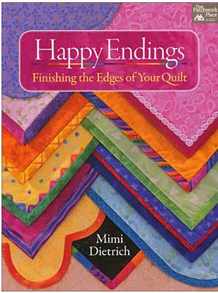
Happy Endings
By Mimi Dietrich
Go ahead-finish those edges of your quilt with style and pizzazz! Discover dozens of ways to finish your quilts in this great re-release. Find new ideas for quilt backings, battings and hanging sleeves, and don’t forget the borders! Projects range from easy to advanced.

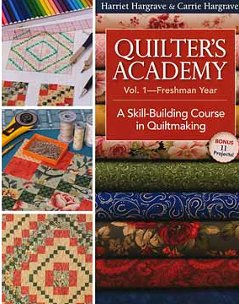
Quilter’s Academy Vol.1
By Harriet Hargrave & Carrie Hargrave
This must-have course guides beginners step-by-step throughout the fundamentals of quilt making: from setting up a sewing space to binding and finishing their first quilts. Classroom-tested lessons draw on Harriet’s many years of teaching experience. Includes nine skill building lessons and complete instructions for making 11 classic quilts.

Ginette Desilets

Media

Here are links to two hidden pages on our web site (access for members
only):

1) Archives (Orientation booklet and Scraps newsletters)
http://westislandquilters.weebly.com/archives.html

2) Show and Tell (slideshows of photos from meetings, events, etc.)
http://westislandquilters.weebly.com/show-and-tell.html

Judy Coffin
Quilting Retreat Info

Hello Everyone,
Please join us for the upcoming Quilting Retreat being held in 21 - 23 March 2014 at L'Ermitage Ste Croix, situated west of Cap St Jacques, just east of L'Anse L’Anse à L’Orme.
During the 13 February 2014 meeting, we will be accepting registrations for the retreat. Please bring your cheque and registration form to reserve your place. The registration form will be found at the end of this newsletter.
Claudia Gass and Josée Glass.
Extras…

The following letter was sent to our Guild thanking everyone for the placemats at Christmas:



