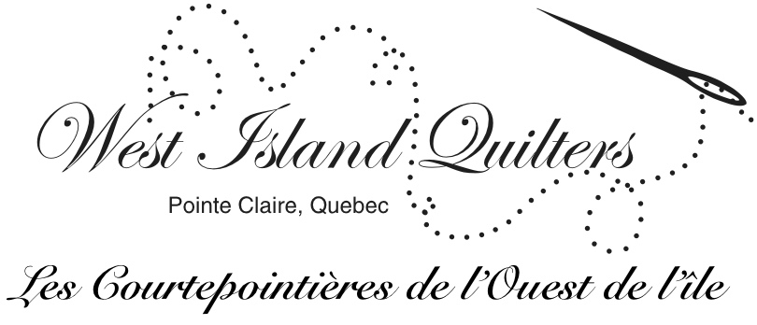

http://westislandquilters.weebly.com

Scraps Newsletter
April 2014

President’s Chatter

It has been a long winter, but we have gained a few extra weeks of quilting time before we head outdoors for all those spring activities.

Mark your calendars for our April 24th and 25th, 2015 quilt show at the Church of the Resurrection.

A sympathy card was sent to Liette on the death of her brother; and Janet's daughter has recovered nicely from her stroke.

The president's challenge is due May 8th. Refer to the September Scraps for requirements or see me.

Our educational raffle quilt was a success. We raised $1110.00 and the quilt was won by a friend of Barbara Fowler, Judy Hung, who is the organist at Valois United Church.

The CQQ raffle tickets are due at our next guild meeting and there are still vacancies in some of the quilt courses.

Happy Quilting

Claudia Gass

Finance

The Bank has told me that all cheques to our organization should be made out to the proper name, "West Island Quilters", rather than W.I. Q. . When you make out your cheques for membership, the retreat, tickets etc. please be sure to use the full name, not the initials. Thanks.

Mary MacMillan

Program News

This month, April 10th, we will have our 'program' during the first meeting of the month due to the availability of our guests. We will be welcoming Renee Porlier, Guilds Director, and Manon Lemoyne, president of CQQ. CQQ stands for Coutrepointe Quebec Quilts, our provincial quilt association. I have too often heard people asking what is CQQ? What’s the benefit of joining? and what do they do? So, to inform all of us, I have invited them to come and share with us their history, vision, and the activities of CQQ. Let's share our passion! And get informed! I hope everyone in the guild can make this meeting and bring a guest if possible ($5). We will have time at the very beginning for our regular guild business, and show and tell. See you then!

By the way, our program for May is blank, so if anyone has an idea or would like to give a demo on some technique or topic, please contact Terrie or Marina.

Terrie Vorsteher and Marina Segalovitch

Hospitality
People often ask me when they are scheduled to bring snacks. I thought it might be helpful to publish the list in the newsletter so the information can be easily accessed, either as a reminder to yourself or in case you have to switch for any reason.
So here are the names of the ladies responsible for kitchen duty until the end of spring. As you will see, we have an opening for May 22. Who would like to fill this spot with Pat?
Please let me know at the next meeting or by email. Many thanks!

April 10 - Ellen Kucharskyi and Stephanie Bleakeny
April 24 - Judy Coffin and Diane Rooney
May 8 - Florence Cleary and Claudia Gass
May 22 - Pat Bradley and ??
Jun 12 - Dinner?

Andree Claveau-Hoyer

Charity

Hope all you ladies are working on your kits. For those who did not receive one, please see me on Thursday. I still have 15 kits left.

Diane Kehle

Library

Last month we had $18.50 at the book box.

I bought a book on back basting applique. Here is the summary:

Discover the easy way to accurately baste shapes in place for applique with this wonderful step-by-step guide. You can learn to easily and accurately baste shapes in place for needle-turn or machine applique - by working from the wrong side of the fabric! This step-by-step book teaches you the basics and beyond with an easy-to-use lesson format that features step-by-step photos, and expert hints and tips. Not only will you master skill-building applique techniques, such as working with layered and overlapped appliques, you'll also create seven unique projects, including table toppers, wall hangings, and a beautiful banner.

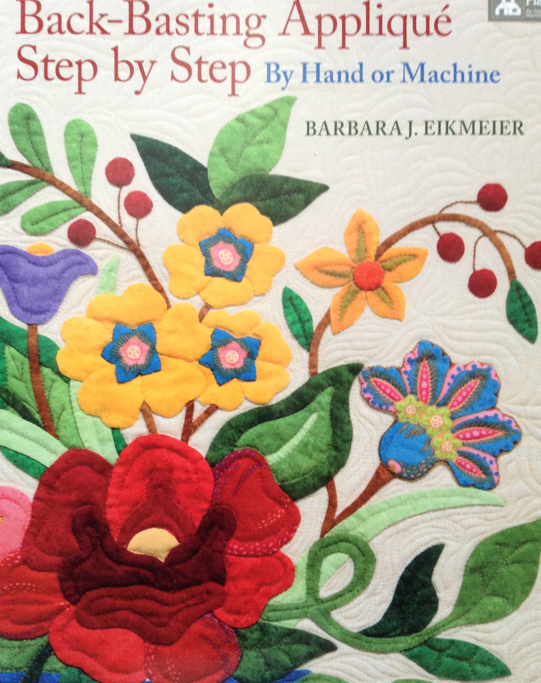

This book and many more are available for you to borrow….

Ginette Desilets

Media

I am looking for a few people who would like to learn about how our WIQ website works. If you are interested, please contact me (see email address below.)

I am also wondering if anyone is interested in starting or contributing to a WIQ blog?

On the topic of web sites and blogs, here are a few web resources I'd like to share with you:

http://www.craftsy.com/ - online courses in quilting and other crafty endeavors
NOTE: There are quite a few free courses, including a fantastic one from the 2013 Modern Quilt Conference featuring talks by Heather Jones, Angela Walters, David and Amy Butler, Jacquie Gering and Mary Fons. _http://www.craftsy.com/class/quiltcon-lecture-series-2013/194

http://www.ohfransson.com/ - quilt blog by Elizabeth Hartman, modern quilter

http://abstractions.deidreadams.com/ - quilt blog by Deirdre Adams, contemporary quilter

http://blog.karenkamenetzky.com/ - quilt blog by Karen Kamenetzky, fiber artist

http://juxtapositionquilts.com/seeds/ - my blog on quilting, creativity, life and whatever else falls out of my brain in the morning :)

Judy Coffin
jcoffin@sympatico.ca

Quilt Shows – Coming up

Deux Montagnes Quilt Guild Show

Saturday April 26th, 2014 10:00am -5:00pm
Sunday April 27th, 2014 10:00-4:00pm
Salle des Veterans – Veterans Hall (Legion)
141 avenue du Grand-Moulin, Deux Montagnes

Ste Anne de Bellevue
Annual, 1st weekend in May

Beaconsfield Quilters' Quilt Show
Next Show Dates (when confirmed):
Contacts Website: www.beaconsfieldquiltersguild.org Email: contact@beaconsfieldquiltersguild.org Phone: Julie Poirier,
Location: Centennial Centre, Macdonald Campus, McGill Univ., 21 111 Lakeshore Rd., Ste Anne de Bellevue,
Hours: Sat 10 - 5, Sun 10 - 3 Admission: Free
Sponsored by: Beaconsfield Quilters' Guild,,
This year's Quilt Challenge ?Who is this? will take you through a gallery of whimsical and realistic portraits while our main event promises to bathe your eyes in endless colors and textures. Vendors, quilt appraisals, a Raffle Quilt and our Tea Room await your company.

Exhibition of Quebec Quilts and Textile Art
Next Show Dates (when confirmed): May 29 - June 1, 2014
Contacts Website: cqq.ca/salon_en/ Email: salon2014-promotion-publicite@cqq.ca Phone: ,
Location: College Andre Grasset, 1001 Cremazie Blvd. E, Montreal, H2M 1M3
Hours: Thurs 10 - 8, Fri 10 - 7, Sat 10 - 5, Sun 10 - 3 Admission: $12
Sponsored by: Quebec Quilts, Montreal,
More that 500 quilts coming from all four corners of the province. We will captivate your senses with colours and textures. Try new techniques or master an old one in our workshops, featuring artists from Canada and the US. Visit our vendors, quilt appraisers, and our Boutique of quilts for sale to find just what you need.

Quilt Canada 2014
St. Catharines (Niagara Region)
ONTARIO
June 11 - 14, 2014

Brock University, St. Catharines, ON

Quilt Canada 2014 - Opening date for Online Registration and Delegate Packages – October 15, 2013

National Juried Show Call for Entry –
Annual General Meeting - Tues. June 10, 2014, 1:00pm
Town Hall Meeting - Tues. June 10, 2014, 3:00pm
NJS Awards Presentation - Tues. June 10, 2014, 7:30pm
National Juried Show Opening - Wed. June 11, 2014 @ 10am
Merchant Mall open - Wed. June 11 – Sat June 14, 2014 @ 10am

Extras…
Raffle quilt:
Reminder please to all that Debby would like to have all blocks back by the end of April



